"What will you be when you grow up?" - This proves to be one of the toughest questions to answer by secondary school students, and I couldn't tell you why... Do you know?
But, at least one of our students, Cheng Tsz-lok, Claudio, clearly has it down and he's got some pretty interesting reasons for it too!
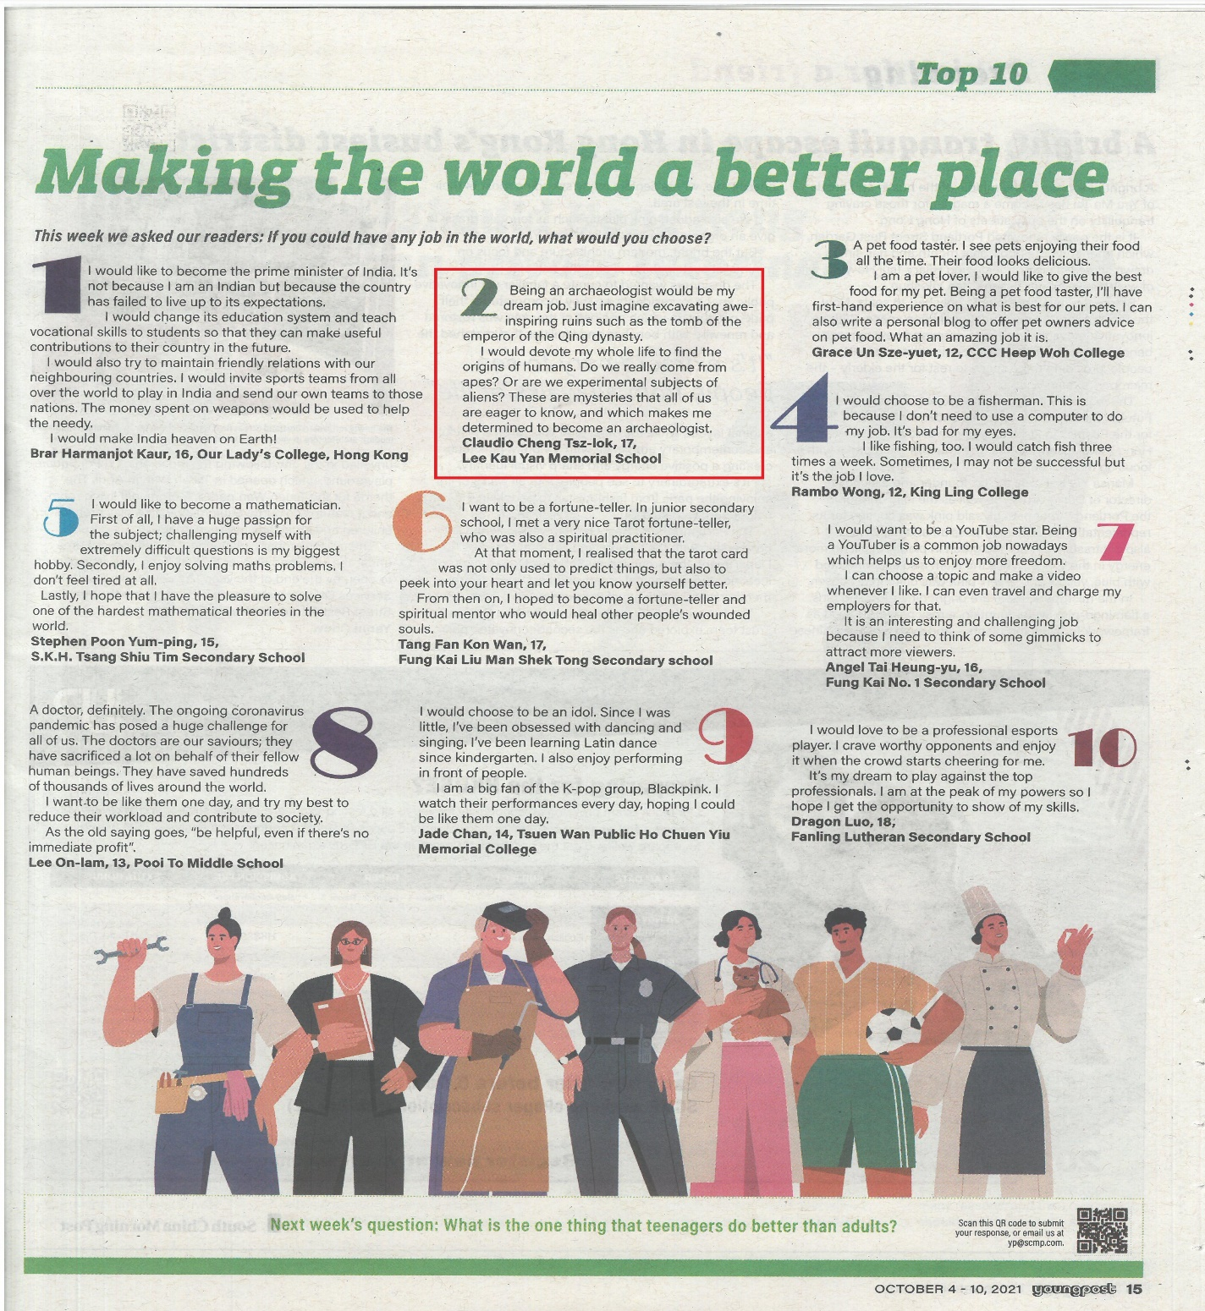
Young Post, 5 October 2021
https://www.scmp.com/yp/discover/your-voice/article/3150879/top-10-if-you-could-have-any-job-world-what-job-would-you

